GEN_AI LAB 2
Name | Shiva Dhanush S
USN | 1RVU23CSE428
Date | 08-04-2026
Title | AI Applications and Frameworks

Overview: This report documents three practical AI workflows completed as part of Lab 2. The exercises move from a ready-to-use transformer pipeline, to transfer learning in computer vision, and finally to data-driven analysis for salary intelligence. Each section explains the goal, tools, implementation logic, and observations in a more detailed form than the source reference.

1. AI Sentiment Analysis Application
Objective: To build a lightweight sentiment analysis application that accepts free-form text and predicts whether the underlying opinion is positive or negative.
Tools and Frameworks: Python, Hugging Face Transformers, Gradio, and a pre-trained sentiment-analysis pipeline.
Concept: Sentiment analysis is a Natural Language Processing task in which a model interprets the emotional orientation of text. By using a pre-trained transformer pipeline, the application can perform strong inference immediately without collecting or training a custom dataset.
Implementation Summary: The application imports the transformers pipeline and initializes a sentiment classifier. A helper function receives user text, passes it through the model, extracts the label and score, and formats the result for display. Gradio is then used to expose the function through a browser-based interface with input and output text boxes.
Working Procedure: The following ordered steps were followed while building and testing the application:
- Install the required libraries and import the transformer pipeline and Gradio modules.
- Load the pre-trained sentiment model using the built-in sentiment-analysis task.
- Define an analyze_text function that returns both the predicted label and rounded confidence score.
- Create a Gradio interface with a single text input and a text output panel.
- Launch the interface and validate it with sample sentences representing positive and negative opinions.
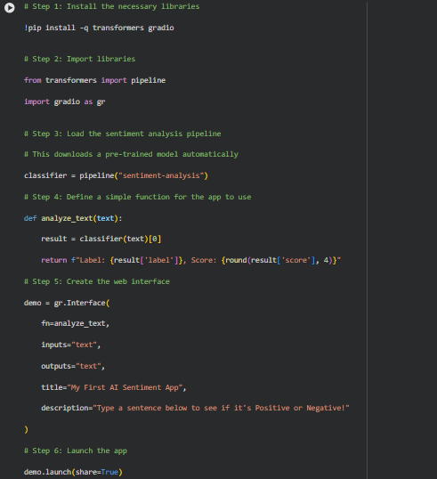
Figure 1. Code snapshot for the sentiment analysis application.
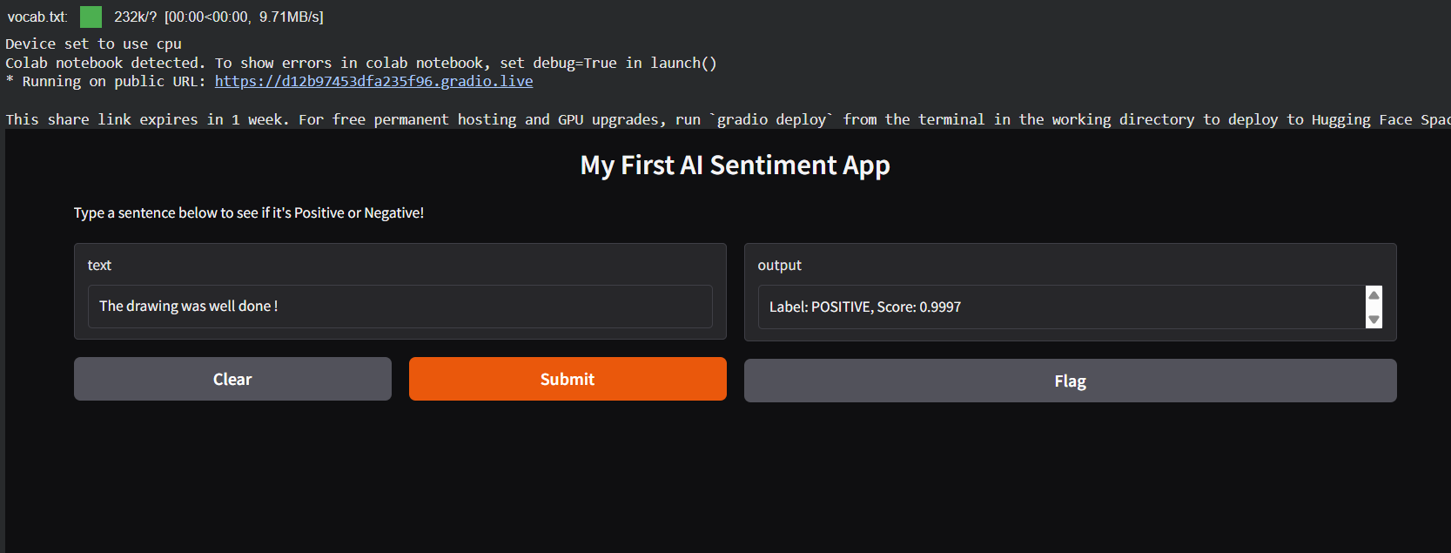
Figure 2. Output of the Gradio-based sentiment analysis interface.
Observation: The interface correctly classifies the sample text as positive with a high confidence value, demonstrating how quickly transformer pipelines can be converted into usable applications. The exercise also shows the importance of UI wrappers such as Gradio for rapid prototyping and demonstration.

2. FastAI Image Classification Using Transfer Learning
Objective: To create an image classifier that distinguishes between bird photographs and forest photographs using the FastAI library and transfer learning.
Tools and Frameworks: FastAI, duckduckgo_search, Python pathlib utilities, and the ResNet18 convolutional neural network architecture.
Concept: Instead of training a deep network from scratch, transfer learning reuses a model that has already learned general visual features from a large corpus of images. This reduces the data requirement and speeds up training while still achieving useful performance.
Dataset Preparation: Images are collected automatically using keyword-based web search. The retrieved files are organized into class folders, cleaned, resized, and prepared through the FastAI DataBlock pipeline so that the learner can consume them in a structured format.
Training Logic: A DataBlock is configured with image and category blocks, a random validation split, a label function based on folder names, and resizing transforms. The model is then created using vision_learner with a ResNet18 backbone and fine_tune is used to adapt the pre-trained weights to the custom two-class problem.
Workflow Highlights: This implementation emphasizes a top-down FastAI approach in which the training loop is expressed with high-level APIs while still supporting disciplined data preparation.
- Search queries are used to gather separate sets of bird and forest images.
- Downloaded images are stored in class-specific folders inside the working dataset directory.
- A short delay is introduced between requests to avoid rate limiting during image collection.
- The images are resized to a uniform resolution for stable batching and model training.
- The final learner predicts the class of a new unseen image and returns probability values.
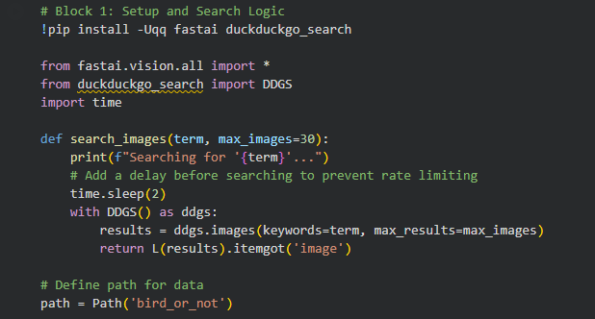
Figure 3. FastAI setup for imports and image-search logic.
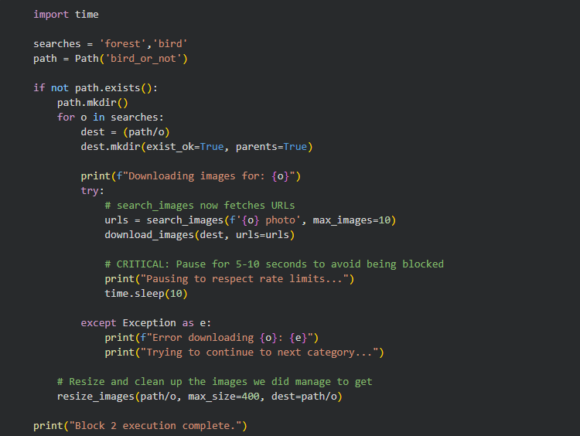
Figure 4. Dataset creation and controlled image download procedure.
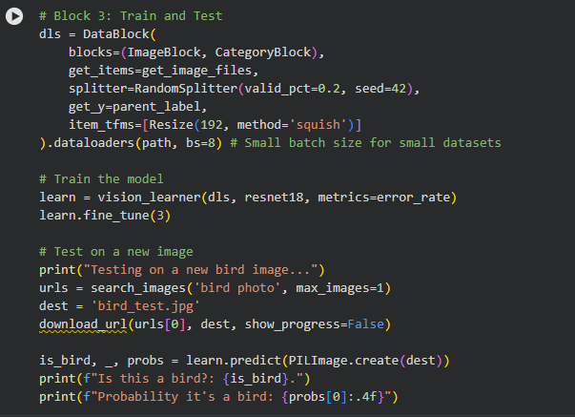
Figure 5. DataBlock configuration, model training, and testing stage.
Observation: This experiment demonstrates how FastAI reduces boilerplate when building vision systems. The combination of automatic data pipelines, transfer learning, and concise training commands makes it practical to build a classifier even with a relatively small custom dataset.

3. Job Salary Intelligence Analysis with Python
Objective: To examine a job-salary dataset and extract meaningful insights about roles, compensation, hiring patterns, and descriptive statistics using Python data-analysis tools.
Tools and Frameworks: Python, Pandas, and Matplotlib for tabular analysis and plotting.
Concept: AI systems are frequently used together with analytics pipelines. Before model building or decision support, raw tabular data must be inspected, summarized, and visualized so that hidden patterns become understandable. This section focuses on exploratory analysis rather than predictive modeling.
Dataset Insight: The dataset contains job ratings, company names, job titles, salary values, number of reported salaries, locations, employment status, and broad job-role labels. Studying these attributes helps reveal which roles and cities dominate the available records and how compensation changes across domains.
Analysis Summary: The workflow begins by loading the dataset into a DataFrame and reviewing its structure. Descriptive statistics are then calculated across numeric and categorical columns. Finally, average salary is aggregated by job role and visualized with a bar chart to compare high-paying categories.
Interpretation: From the reference output, Bangalore appears prominently in the dataset, full-time employment dominates the records, and software-oriented roles such as Database, SDE, iOS, Mobile, and Backend show strong average salary values. This kind of summary can support career guidance, market benchmarking, or downstream machine-learning tasks such as salary prediction.
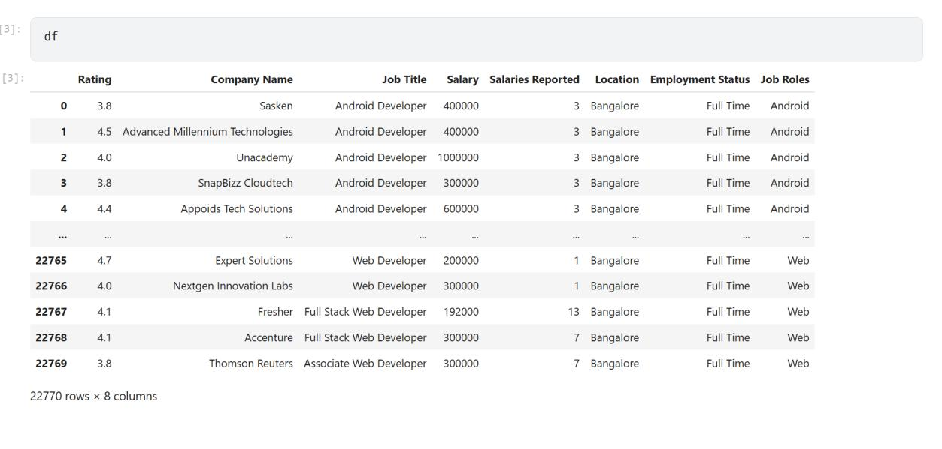
Figure 6. Initial DataFrame preview showing the job-salary dataset structure.
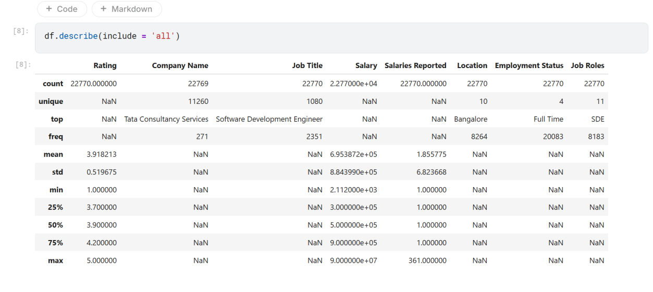
Figure 7. Descriptive summary statistics generated for the dataset.
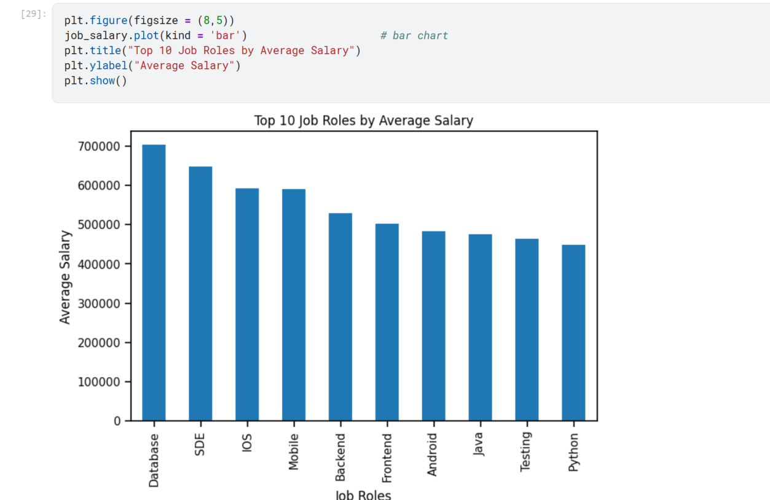
Figure 8. Bar-chart output showing top job roles by average salary.
Observation: The visualization makes role-wise salary differences immediately visible and demonstrates why exploratory data analysis is an essential first step in any AI or data-science workflow. Clean summaries and charts help validate data quality and guide more advanced modelling decisions.

Conclusion
Lab 2 highlights three complementary dimensions of modern AI practice. The sentiment analysis task shows rapid deployment using pre-trained NLP models, the FastAI exercise demonstrates efficient transfer learning for computer vision, and the salary analysis section illustrates how structured data can be transformed into actionable insights through statistical exploration and visualization. Together, these exercises strengthen practical understanding of frameworks, workflows, and application-oriented AI development.

